PHASE 3 PROJECT WALKTHROUGH

Introduction
This phase implements a ride-sharing event streaming pipeline using Apache Kafka and Python. A producer simulates ride events containing ride details such as ride ID, driver ID, rider ID, status, location, and timestamp, and publishes them to the ride.events topic. A consumer processes these events and forwards only rides with the status COMPLETED to the ride.completed topic.
Another consumer reads completed rides, calculates the total completed rides and estimated earnings for each driver using a fixed rate of USD 5 per ride, and publishes the results to driver.earnings. A simple CLI is also provided to display the top 5 drivers based on completed rides, demonstrating real-time event processing and analytics using Kafka.

Architecture diagram:

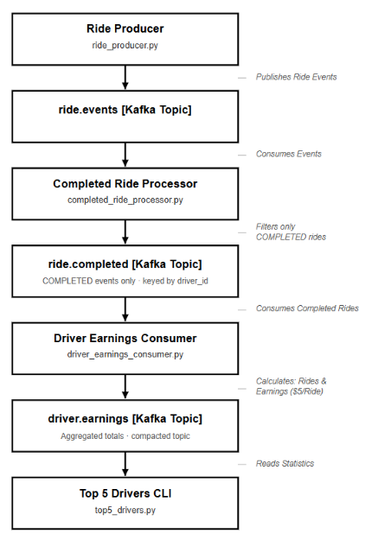

Kafka Topics Used
Step 1 - Topic 1: ride.events
This topic stores all ride events generated by the producer. Each event contains details such as ride ID, driver ID, rider ID, ride status, location coordinates, and timestamp.
Possible statuses:
- REQUESTED
- ACCEPTED
- COMPLETED
- CANCELLED
Topic 2: ride.completed
This topic stores only rides with the status COMPLETED. A consumer filters completed rides from ride.events and forwards them to this topic for further processing.
Topic 3: driver.earnings
This topic stores aggregated driver statistics, including the total number of completed rides and estimated earnings calculated using a fixed rate of USD 5 per ride.
Step 2 – Produce Ride Events
The ride_producer.py script simulates ride-sharing events and publishes them to the ride.events topic.
Each ride event contains:
- ride_id
- driver_id
- rider_id
- status
- latitude
- longitude
- timestamp
Example:
{
"ride_id": "R002",
"driver_id": "D002",
"rider_id": "U002",
"status": "COMPLETED"
}
Output:
The producer sends ride events continuously to Kafka.
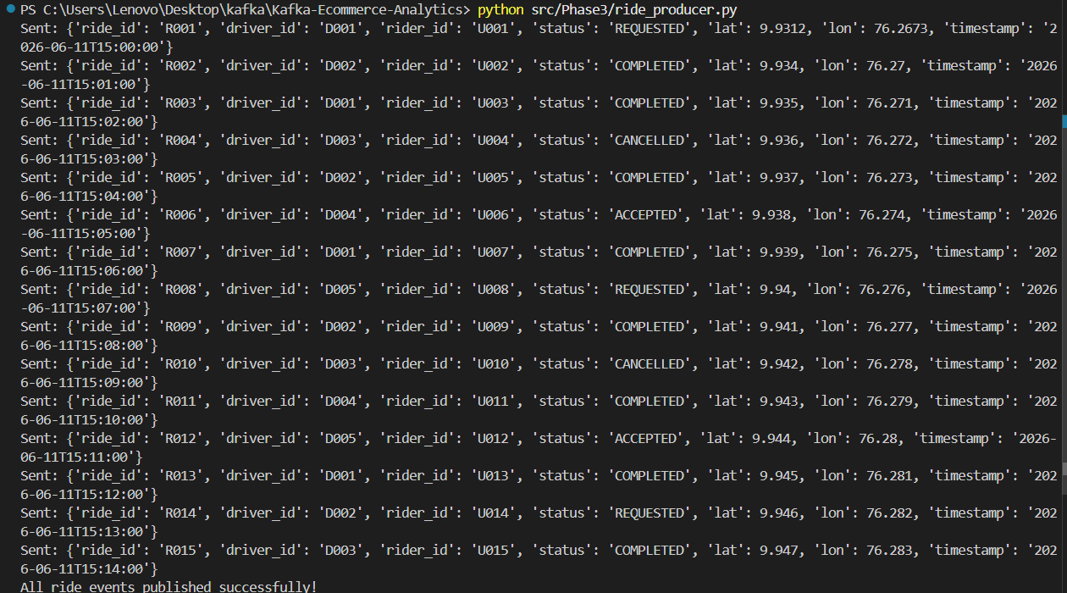
Step 3 – Filter Completed Rides
The completed_consumer.py application consumes messages from the ride.events topic.
Processing logic:
- Read each ride event.
- Check the ride status.
- If the status is COMPLETED, publish the event to the ride.completed topic.
- Ignore REQUESTED, ACCEPTED, and CANCELLED rides.
Output:
This creates a dedicated stream containing only completed rides.
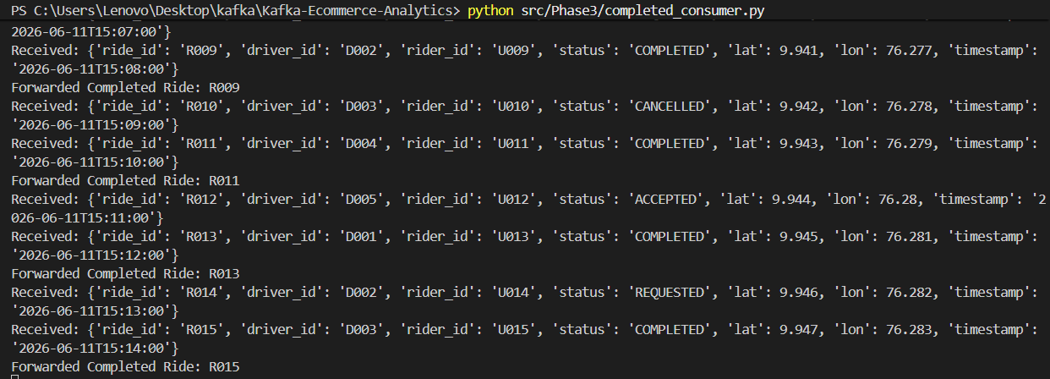

Step 4 – Calculate Driver Earnings
The earnings_driver.py consumer subscribes to the ride.completed topic.
For every completed ride:
- Increment the completed ride count.
- Add a fixed earning of $5.
Example:
Driver D002
- Completed Ride 1 → $5
- Completed Ride 2 → $10
Output:
The consumer maintains a running total for each driver.
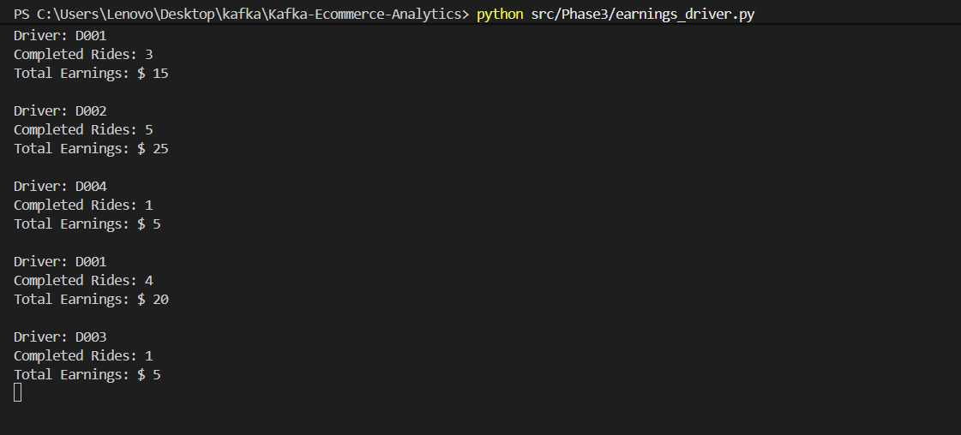

Step 5 – Display Top Drivers
The top_drivers.py consumer reads completed ride events and maintains ride counts per driver.
Drivers are sorted by completed rides and displayed in descending order.
Example output:
- D002 → 4 rides
- D001 → 3 rides
- D004 → 2 rides
- D003 → 1 rides

Output:
This provides a simple CLI-based leaderboard.
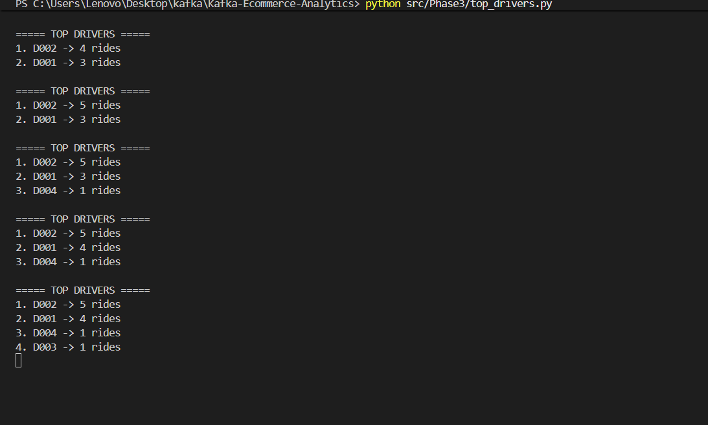

Result
The Phase 3 pipeline successfully demonstrates:
- Event production using Kafka Producer
- Event filtering using Kafka Consumer
- Topic-to-topic event processing
- Driver earnings aggregation
- Real-time analytics using Kafka
This implementation follows an event-driven architecture and showcases how Kafka can be used for streaming data pipelines in ride-sharing applications.

